INCOME TAX CALCULATION SYSTEM

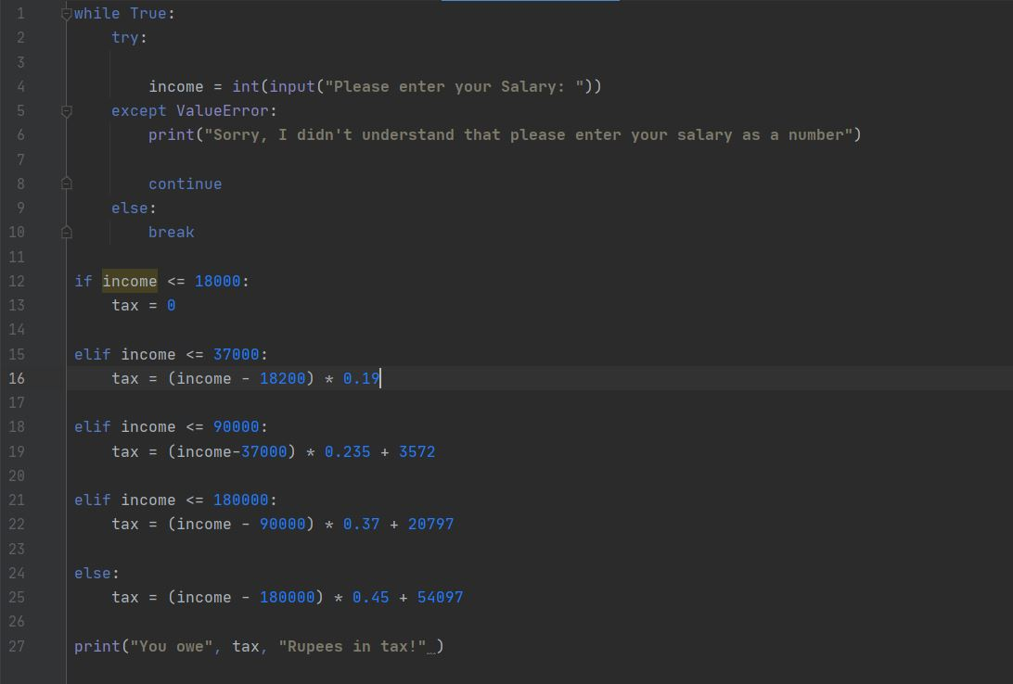

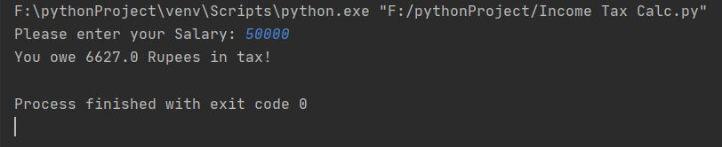

PROGRAMME CODE

while True:  
 try:  
  
 income = int(input(**"Please enter your Salary: "**))  
 except ValueError:  
 print(**"Sorry, I didn't understand that please enter your salary as a number"**)  
  
 continue  
 else:  
 break  
  
if income <= 18000:  
 tax = 0  
  
elif income <= 37000:  
 tax = (income - 18200) * 0.19  
  
elif income <= 90000:  
 tax = (income-37000) * 0.235 + 3572  
  
elif income <= 180000:  
 tax = (income - 90000) * 0.37 + 20797  
  
else:  
 tax = (income - 180000) * 0.45 + 54097  
  
print(**"You owe"**, tax, **"Rupees in tax!"** )

PREPAIRED BY:

* SUMIT PRADHAN (11912387)
* RAVI RAJ ()